**Explainer on COVID19 vaccination, fertility, pregnancy and breastfeeding**

**Victoria Male, Lecturer in Reproductive Immunology at Imperial College London**

[**v.male@imperial.ac.uk**](mailto:v.male@imperial.ac.uk)

[**@VikiLovesFACS**](https://twitter.com/VikiLovesFACS)

**1. I heard that the COVID19 vaccine might reduce fertility in young women. Is this true?**

No. In fact, multiple strands of evidence tell us that COVID19 vaccines do not reduce fertility.

**2. What is the evidence that the COVID19 vaccine will not reduce fertility?**

Although pregnant people were not included in the first round of trials, and participants were asked to avoid becoming pregnant, nonetheless a number of people became pregnant by accident. The accidental pregnancies occurred equally across the vaccinated and the non-vaccinated groups, which tells us that vaccines did not prevent pregnancy. The people who became pregnant have been followed closely, and are having normal pregnancies. You can find the accidental pregnancy data [here (AZ)](https://assets.publishing.service.gov.uk/government/uploads/system/uploads/attachment_data/file/963928/UKPAR_COVID_19_Vaccine_AstraZeneca_23.02.2021.pdf), [here (Moderna)](https://www.fda.gov/media/144434/download), [here (Pfizer)](https://www.fda.gov/media/144246/download) and [here (Janssen).](https://www.fda.gov/media/146217/download)

|  |  |  |  |  |  |  |
| --- | --- | --- | --- | --- | --- | --- |
| Vaccine | Control group | | | Vaccinated group | | |
| Participants | Pregnancies | Miscarriages (rate) | Participants | Pregnancies | Miscarriages (rate) |
| Pfizer | 18,846 | 12 | 1 (8%) | 18,860 | 11 | 0 (0%) |
| Moderna | 15,170 | 7 | 1 (14%) | 15,181 | 6 | 0 (0%) |
| AstraZeneca | 5,829 | 9 | 3 (33%) | 5,807 | 12 | 2 (17%) |
| Janssen (J&J) | 21,895 | 4 | 1 (25%) | 21,888 | 4 | 1 (25%) |

Following the general rollout, we have been able to collect further data about the effect of the vaccines on human fertility. In IVF patients, vaccination against COVID19 does not affect ovarian function, egg quality, fertilisation or clinical pregnancy rate. You can read these studies [here](https://www.medrxiv.org/content/10.1101/2021.04.09.21255195v1), [here](https://www.medrxiv.org/content/10.1101/2021.05.30.21258079v1.full.pdf) and [here](https://www.sciencedirect.com/science/article/pii/S2666334121000684). In the wider population, [almost 5000 people](https://www.nejm.org/doi/full/10.1056/NEJMoa2104983?query=featured_home) in the USA had reported post-vaccination pregnancies by the end of March 2021, although this will underestimate the true number, since it only includes participants in the USA’s active tracking programme V-safe.

The vaccine works by instructing our bodies to make antibodies that bind to a viral protein called Spike. This stops the virus from infecting our cells. The claim that the vaccine might reduce fertility came from the idea that there are proteins in the placenta that have some similarities with Spike, so the antibodies that block Spike might also attach to the placenta. But the viral and placental proteins are not similar enough that we would expect this to happen and laboratory studies have now confirmed that this is the case. You can read more about this [here](https://www.medrxiv.org/content/10.1101/2021.05.23.21257686v1). If antibodies against Spike did cause problems for the placenta, we would expect to see miscarriages in pregnant people who become infected with COVID19, and we don’t see this. You can find studies [here](https://link.springer.com/article/10.1007/s00404-020-05848-0) and [here.](https://www.ajog.org/article/S0002-9378(20)31177-7/pdf)

**3. I heard that the UK government recommended that people should not get the vaccine if they are pregnant or planning on becoming pregnant within the next few months. Is this true?**

Not anymore. Pregnant people were not included in the first round of trials, and participants were asked to avoid becoming pregnant, so the UK government initially advised that the same measures be followed for the wider use of the vaccine. From the 30th December 2020, the UK government advised that people who are trying to conceive or breastfeeding should be offered the vaccine if they are otherwise eligible, and those who are pregnant and at high risk should be offered the vaccine.

**The advice in the UK was updated on the 16th April 2021. The current advice is that all pregnant people should be offered either the Pfizer or Moderna vaccine, where they are available. People who are trying to conceive or breastfeeding can be offered any vaccine. You can read the new guidance** [**here**](https://www.gov.uk/government/news/jcvi-issues-new-advice-on-covid-19-vaccination-for-pregnant-women)**.**

The USA approved the vaccine in pregnancy from the outset and the [majority of states](https://www.nbcnews.com/health/health-news/map-here-are-states-where-pregnant-women-can-get-covid-n1259291) are now prioritising pregnant people for vaccination.

**4. I am not pregnant, but I would like to have children later. Should I get the vaccine?**

There is no evidence that the vaccine will reduce your chances of getting pregnant later and the UK government recommends that people who are trying to get pregnant should receive the vaccine if they are otherwise eligible. For people in your position, there is no reason not to get the vaccine if you are offered it.

**5. I am pregnant. Should I get the vaccine if I am offered it?**

It is understandable that pregnant people might feel wary of getting the vaccine, since pregnant people were not included in the first round of clinical trials. Trials of the Pfizer and Janssen vaccines in pregnancy are currently underway.

There are risks associated with catching COVID19, particularly in the second half of pregnancy. Pregnant COVID19 patients are more likely to need intensive care than COVID19 patients who are not pregnant. Preterm birth and stillbirth are more common than normal in pregnant COVID19 patients, and their babies are more likely to be admitted to the neonatal unit. The BMJ provides a regularly updated summary of the research in this area, which you can find [here.](https://www.bmj.com/content/370/bmj.m3320.long)

The safety of using these vaccinations during pregnancy is being carefully monitored and no concerns have arisen so far.

Because of the increased risk from COVID19 during pregnancy and the reassuring safety profile of the vaccines in this group, the UK government now advises that [all pregnant people should be offered the COVID-19 vaccine at the same time as the rest of the population, based on their age and clinical risk group.](https://www.gov.uk/government/news/jcvi-issues-new-advice-on-covid-19-vaccination-for-pregnant-women) In the USA, [majority of states](https://www.nbcnews.com/health/health-news/map-here-are-states-where-pregnant-women-can-get-covid-n1259291) are now prioritising pregnant people for vaccination.

Babies of vaccinated mothers do not have any anti-spike IgM, indicating that the vaccines themselves do not cross the placenta. You can see the data on this [here](https://www.ajog.org/article/S0002-9378(21)00215-5/pdf) and [here](https://www.jci.org/articles/view/150319), with an explanation on the interpretation of the studies [here](https://twitter.com/VikiLovesFACS/status/1397131519618162689?s=20). Vaccination is also not associated with any placental pathology. You can read about this [here](https://journals.lww.com/greenjournal/Fulltext/9900/Severe_Acute_Respiratory_Syndrome_Coronavirus_2.206.aspx).

On the other hand, some protective antibodies made by the mother (IgG) cross the placenta. You can find reports of this occurring [here](https://bmcpediatr.biomedcentral.com/articles/10.1186/s12887-021-02618-y), [here](https://www.sciencedirect.com/science/article/pii/S0002937821001873?via%3Dihub), [here](https://www.ajog.org/article/S0002-9378(21)00215-5/pdf), [here](https://www.biorxiv.org/content/10.1101/2021.04.05.438524v1.full.pdf), [here](https://jamanetwork.com/journals/jama/fullarticle/2780202), [here](https://www.jci.org/articles/view/150319) and [here.](https://www.medrxiv.org/content/10.1101/2021.03.11.21253352v1) This might be expected to give the baby some protection against COVID19, although more research is being done to find this out.

**6. I would like detailed information about the outcomes for the pregnant people who have so far received the vaccine. Where can I find it?**

In the USA, the safety of the new COVID19 vaccines is being monitored in a number of ways. One of these is an active surveillance programme called V-safe. V-safe recruits people at vaccination and actively tracks their outcomes.

The V-Safe pregnancy registry enrolled 3958 participants between 14th December 2020 and 28th February 2021. By 30th March, 827 of these people had completed their pregnancy, of which 712 resulted in a live birth. The rates of adverse pregnancy events were the same in those who received a COVID19 vaccination during pregnancy as in the general pregnant population. You can read more [here](https://www.nejm.org/doi/full/10.1056/NEJMoa2104983?query=featured_home).

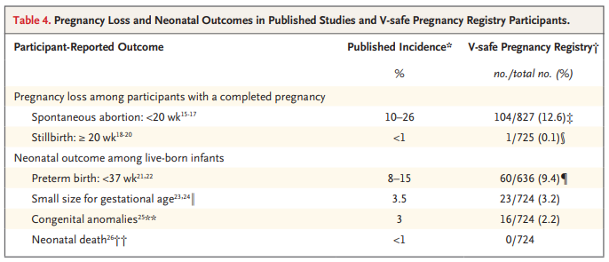

A smaller study, of 140 people vaccinated during pregnancy, compared to a cohort of unvaccinated people giving birth at the same time, also showed that vaccination was not associated with an increased risk of any adverse outcomes at birth. You can read more about this study [here](https://www.medrxiv.org/content/10.1101/2021.05.17.21257337v1.full.pdf).

The USA also has a passive monitoring programme called VAERS. This collects information that doctors, patients or their families report. By the 3rd May 2021, more than 106,000 pregnant people had received either the Pfizer, the Moderna or the Janssen vaccine in the USA. There have been 432 reports of adverse events from these people, most of which have been mild side-effects which we already know to be common in people who receive the vaccine.

In terms of pregnancy-specific problems, by the 3rd May, 91 miscarriages, 20 preterm births, 11 cases of pre-eclampsia or intrauterine growth restriction and 7 stillbirths have been reported, among more than 106,000 people. This is in line with the rate at which these events normally occur.

At a White House briefing on the 5th April, at which point 70,000 pregnant people had been vaccinated, the Director of the National Institute of Allergy and Infectious Diseases, Dr. Anthony Fauci said “things look very good for the association between vaccination and protecting pregnant women from adverse outcomes from themselves and their fetus”. You can read a transcript of the briefing [here](https://www.whitehouse.gov/briefing-room/press-briefings/2021/04/05/press-briefing-by-white-house-covid-19-response-team-and-public-health-officials-24/). At a briefing on the 23rd April, the Director of the CDC, Dr. Rochelle Walensky, said, “Importantly, no safety concerns were observed for people vaccinated in the third trimester, or safety concerns for their babies.” You can read a transcript of the briefing [here](https://www.whitehouse.gov/briefing-room/press-briefings/2021/04/23/press-briefing-by-white-house-covid-19-response-team-and-public-health-officials-31/).

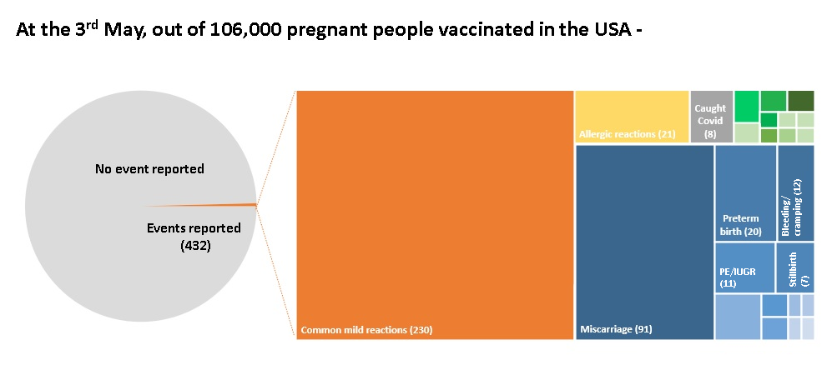

In the UK, we also have both active and passive surveillance systems, both of which are run through the Yellow Card reporting system. The UK’s active surveillance system is relatively new, and no report has yet been published from this.

The UK data on the safety of COVID19 vaccines during pregnancy collected through passive surveillance is in line with the US data, with no sign of adverse events occurring more often than in the general pregnant population. The reports are regularly updated, and you can find them [here.](https://www.gov.uk/government/publications/coronavirus-covid-19-vaccine-adverse-reactions/coronavirus-vaccine-summary-of-yellow-card-reporting)On the 16th April, the JCVI, which advises the UK government on vaccination policy, released a statement saying that “there have been no specific safety concerns from any brand of COVID-19 vaccines in relation to pregnancy.” You can read the statement [here](https://www.gov.uk/government/news/jcvi-issues-new-advice-on-covid-19-vaccination-for-pregnant-women).

**7. I am breastfeeding. Should I get the vaccine if I am offered it?**

There is no known risk associated with giving non-live vaccines whilst breastfeeding and no safety signals have appeared in breastfeeding people or their babies. The UK government advises that breastfeeding people should be offered the vaccine if they are otherwise eligible.

Two studies have shown that the vaccine does not pass into breast milk. You can read them [here](https://www.medrxiv.org/content/10.1101/2021.03.05.21252998v1) and [here](https://www.medrxiv.org/content/10.1101/2021.05.23.21257686v1). However, the protective antibodies that your body makes do. You can read studies showing this [here](https://www.sciencedirect.com/science/article/pii/S0002937821001873?via%3Dihub), [here](https://jamanetwork.com/journals/jama/fullarticle/2778766), [here](https://www.medrxiv.org/content/10.1101/2021.03.06.21252603v1.full-text), [here](https://www.medrxiv.org/content/10.1101/2021.02.23.21252328v1), [here](https://jamanetwork.com/journals/jama/fullarticle/2780202) and [here](https://www.medrxiv.org/content/10.1101/2021.05.03.21256416v1.full.pdf). There is also some evidence that T cells that respond to COVID19 get into breast milk. You can read about this [here](https://www.medrxiv.org/content/10.1101/2021.05.03.21256416v1.full.pdf). These antibodies and T cells are expected to give your baby some protection against COVID19, although more research is being done to find this out.

**If you would like this information in a more formal format, you can find an article based on this document** [**in Nature Reviews Immunology.**](https://www.nature.com/articles/s41577-021-00525-y) **This article was up-to-date when it was submitted on the 19th February 2021 but unlike this explainer, will not be updated as new information comes to light.**

**Revision history**

**Updated 24 January 2021** to include a trial-by-trial breakdown of the outcomes for participants who became pregnant during the trials.

**Updated on 26 January 2021.** Q3. “Following the publication of the data showing that the vaccine is safe in pregnant animals...” changed to “Following the publication of the interim data showing that the vaccine is safe in pregnant animals...” Q5 updated to more closely mirror the language of the JCVI report.

**Updated on 3 February 2021** to incorporate developmental and reproductive toxicity studies using the Oxford/AZ vaccine in mice. I have also changed the link on the risks of COVID-19 infection during pregnancy to point to a living systematic review in the BMJ, which acts as a more comprehensive and up-to-date resource than the individual studies.

**Updated on 10 February 2021** to add the safety data that has so far been collected in the USA and UK.

**Updated on 19 February 2021** to add further safety data collected in the USA and UK.

**Updated on 24 February 2021** to add an easy-reference table summarising the accidental pregnancy data.

**Updated on 3 March 2021** to add the safety data that has been collected through V-safe in the USA, and to update the data that has been collected through the VAERS and Yellow Card schemes.

**Updated on 4 March 2021** to add data about transfer of antibodies across the placenta and through breast milk following vaccination, and to add a link to my article at Nature Reviews Immunology.

**Updated on 11 March 2021** to add data about accidental pregnancies in the Janssen vaccine trial, reformat to move the details of the accidental pregnancies to question 2, and new data about the effects of vaccination on antibodies crossing the placenta and into breast milk. I have also updated the VAERS data, to include data collected to 26 February.

**Updated on 19 March 2021** to update VAERS data, collected to 11 March.

**Updated on 23 March 2021** to add a new study on transfer of antibodies across the placenta, and to update the first preprint that came out on this to its final, published form.

**Updated on 29 March 2021** to add a new study about the transfer of antibodies into breast milk and to update VAERS data, collected to 19 March.

**Updated on 1 April 2021** to add another study looking at transfer of antibodies across the placenta following vaccination.

**Updated on 5 April 2021** to reformat the Question 6 and to add information about the UK’s new active surveillance system.

**Updated on 8 April 2021** to add another study showing that antibodies are transferred across the placenta following vaccination.

**Updated on 9 April 2021** to update VAERS data, collected to 4 April.

**Updated on 13 April 2021** to add another study showing that antibodies are found in breast milk following vaccination

**Updated on 18 April 2021** to reflect the new advice in the UK that all pregnant people should be offered the vaccine, and to update VAERS data, collected to 8 April.

**Updated on 22 April 2021** to incorporate the updated V-safe data.

**Updated on 26 April 2021** to update VAERS data, collected to 16 April

**Updated on 5 May 2021** to update VAERS data, collected to 3 May, and to add a new study on the immune properties of breast milk following vaccination.

**Updated on 14 May 2021** to add a new study on antibodies crossing the placenta and entering breast milk following vaccination

**Updated on 25 May 2021** to add a new study on antibodies crossing the placenta following vaccination

**Updated on 28 May 2021** to add data to show that vaccines do not cross the placenta, and further data to show they don’t cross into breast milk. Also added, data to show that they don’t raise antibodies to the placental protein syncytin, and another study into the outcomes for babies whose mothers are vaccinated during the third trimester of pregnancy.

**Updated on 2 June 2021** to add a study showing no placental pathology is associated with COVID vaccination.

**Updated on 3 June 2021** to add two studies showing no impact of vaccination on fertility in IVF patients.

**Updated on 4 June 2021** to add another study showing no impact of vaccination on pregnancy rate in IVF patients.